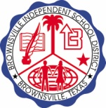
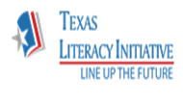
ELEMENTARY FLUENCY INITIATIVE ROUTINE

Monday Cold Read (Report Card Score) Test every student. Distribute passage for homework.

Tuesday Introduce RAPID WORD RECOGNITION CHART.
The teacher READS PASSAGE for the first time stressing Prosody and Speed. “Read it just right so that we can understand what we are reading.” Teacher asks a few DOK questions. 10 minutes maximum

Wednesday 1 minute review RAPID WORD RECOGNITION CHART
READ PASSAGE “Today, we will read the passage paying close attention to punctuation. Get out your highlighters and let’s highlight all the punctuation marks we see.” 10 minutes maximum

Thursday 1 minute review RAPID WORD RECOGNITION CHART
“Today, we will use pencil swings under words that will be phrased together when we read the passage. Phrasing as we read helps us to understand what we are reading. Remember, the purpose of reading is comprehension. Follow me as we mark our passage with pencil swings under the phrases.” 10 minutes maximum

Friday FINAL (Practiced) Read Test every student to see improvement for the week. This is NOT the report card score.

